Experiment 10
DEPLOYMENT OF A WEB APPLICATION
USING A PLATFORM AS A SERVICE (PaaS) ENVIRONMENT

1. Aim
To study the Platform as a Service (PaaS) cloud service model and deploy a simple web application on a PaaS platform.

2. Objectives
- Understand PaaS and the responsibilities shared between the provider and developer.
- Create a simple web application with a defined runtime and dependencies.
- Deploy the application using a managed application platform.
- Verify the deployed application using its public URL and runtime logs.
- Understand environment variables, scaling, monitoring, and basic deployment security.

3. Theory

3.1 What is Platform as a Service (PaaS)?
Platform as a Service is a cloud service model that provides a managed environment for developing, deploying, and running applications. The provider manages much of the underlying infrastructure, operating system, runtime platform, and platform maintenance. The developer focuses primarily on application code, dependencies, application configuration, and data.
PaaS can reduce the work required to provision and maintain servers. Many platforms provide deployment from a source-code repository, managed build processes, environment variables, logs, health checks, and scaling features. Exact capabilities and pricing depend on the selected provider and plan.

3.2 Examples of PaaS platforms
- Heroku — managed application deployment platform.
- Google App Engine — managed application hosting on Google Cloud.
- Azure App Service — managed hosting for web apps and APIs.
- AWS Elastic Beanstalk — application deployment and environment management on AWS.
- Render or similar managed platforms — deploy applications from a repository or build configuration.

3.3 PaaS architecture
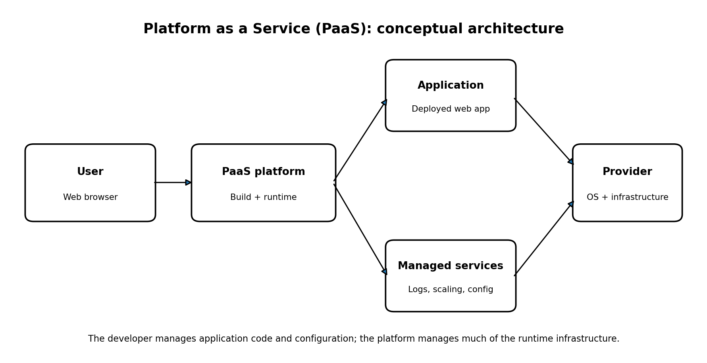
Figure 1: Conceptual PaaS architecture. The platform provides the runtime and managed operational features while the developer supplies the application.

4. Requirements
- Computer with an internet connection and a modern web browser.
- A code editor such as Visual Studio Code or a simple text editor.
- A Git repository or the deployment method supported by the selected PaaS provider.
- A PaaS account with an available service plan; a student or free option may be used if currently offered.
- A simple web application and its required runtime dependencies.
Cost note: free tiers and service limits change. Review the provider's current pricing and remove unused test resources when the experiment is complete.

5. Application development

5.1 Create the project
Create a folder named paas-web-demo. The following example uses Python and Flask because it is small and easy to verify. If your course requires a particular platform or language, the same deployment principles can be adapted.

File 1: app.py
import os
from flask import Flask
app = Flask(__name__)
@app.route("/")
def home():
return <h1>Welcome to my PaaS Web Application</h1><p>Deployment successful.</p>
if __name__ == "__main__":
port = int(os.environ.get("PORT", "5000"))
app.run(host="0.0.0.0", port=port)

File 2: requirements.txt
Flask

File 3: Procfile (if required by the selected platform)
web: gunicorn app:app
The Procfile specifies the web process for platforms that support this convention. The application uses the PORT environment variable when running directly. For a production deployment, the platform's recommended WSGI server and start-command configuration should be used.

5.2 Add a production server dependency
Flask
gunicorn
Save the two package names in requirements.txt. A platform that uses a Procfile can start the app with gunicorn app:app. If the platform supplies its own build and start settings, follow those instructions.

6. Deployment procedure (generic PaaS workflow)
- Create an account with a PaaS provider and open its application dashboard.
- Create a new web service or application and connect the Git repository containing app.py, requirements.txt, and the optional Procfile.
- Select the appropriate Python runtime or let the platform detect it from the repository.
- Set the build/install command if required, for example: pip install -r requirements.txt.
- Set the start command to gunicorn app:app if the platform requires an explicit command and Gunicorn is included in requirements.txt.
- Choose a permitted development plan and region. Review the expected charges before creating the service.
- Start the deployment and wait for the build and release process to complete.
- Open the service URL provided by the platform.
- Confirm that the page displays “Welcome to my PaaS Web Application” and “Deployment successful.”
- Open the deployment logs if the build fails or the application does not start. Correct the issue and redeploy.

7. Deployment workflow
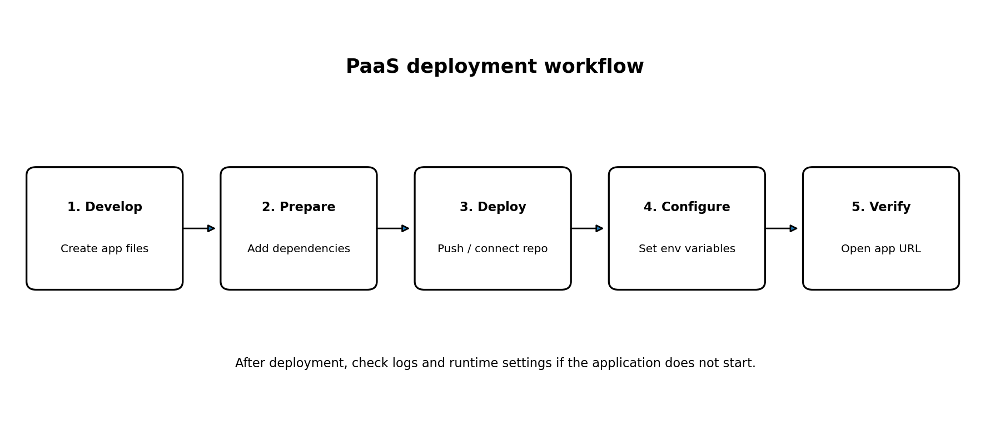
Figure 2: Typical deployment workflow for a web application in a PaaS environment.

8. Testing and verification
Test | Procedure | Expected result
Build | Review the platform build/deployment log | Dependencies install and build completes successfully
Application startup | Review runtime logs | Web process starts without a fatal error
HTTP access | Open the platform-provided URL | The home page displays the welcome message
Configuration | Confirm the app uses the configured PORT variable when required | The app listens on the platform-assigned port
Redeployment | Make a harmless text change and deploy again | Updated page appears after the new release
Failure diagnosis | Review logs after an intentionally incorrect local configuration (do not expose secrets) | The error can be identified and corrected
Record actual screenshots and outputs from your own deployment. These expected results are not proof that a live service has been deployed.

9. PaaS vs IaaS vs SaaS
Model | Provider primarily manages | Customer primarily manages | Example
IaaS | Physical infrastructure and virtualization | OS, runtime, applications, data, and many configurations | Virtual machines
PaaS | Infrastructure, OS, and application runtime/platform services | Application code, data, app configuration, and access policies | Managed web-app platform
SaaS | Complete application service and underlying stack | Usage settings, users, and customer data/configuration where provided | Web-based email or office software

10. Advantages of PaaS
- Reduces server and operating-system administration.
- Speeds up application deployment and iteration.
- Often integrates source control, build logs, runtime logs, and monitoring.
- May provide managed scaling and health checks.
- Lets developers focus more on application features than infrastructure management.

11. Limitations and security considerations
- Platform-specific buildpacks, configuration, or APIs may create vendor lock-in.
- Runtime, storage, bandwidth, and instance limits vary by plan.
- The application must handle errors, input validation, authentication, and authorization correctly.
- Store secrets in the platform's environment-variable or secret-management facility, not in source code.
- Use HTTPS, keep dependencies updated, and restrict administrative access.
- Review logs carefully; avoid logging passwords, tokens, or personal information.
- Understand where application data is stored, how backups work, and how to export data if migrating.

12. Result
The experiment outlines how to prepare a simple Python web application, configure its dependencies, deploy it to a PaaS environment, and verify it using the platform-provided URL and logs. The experiment should be marked successful only after a real deployment completes and the application is accessible. This document provides a reproducible procedure and expected verification criteria, not a claim of a completed live deployment.

13. Conclusion
PaaS simplifies web application deployment by providing a managed runtime and operational platform. Developers supply application code and configuration while the provider manages much of the underlying infrastructure. A successful deployment still requires correct dependencies, start commands, environment configuration, secure secret handling, and verification through logs and the application URL.

14. Viva questions
What is PaaS? A cloud model providing a managed platform to build, deploy, and run applications.
How does PaaS differ from IaaS? PaaS manages more of the operating system and runtime; IaaS gives the user more infrastructure control.
Name two PaaS platforms. Google App Engine and Azure App Service; other examples include Heroku and AWS Elastic Beanstalk.
What is a deployment log? A record of build and application startup events used to diagnose deployment problems.
Why are environment variables used? To provide configuration such as ports and service settings without hard-coding them.
What is a start command? The command the platform runs to launch the web application.
Why is HTTPS important? It encrypts traffic between clients and the deployed application.
What should be checked after deployment? Build status, runtime logs, public URL, response content, and configuration.

15. References
- Google Cloud, App Engine documentation: https://cloud.google.com/appengine/docs
- Microsoft Learn, Azure App Service: https://learn.microsoft.com/azure/app-service/
- AWS Elastic Beanstalk documentation: https://docs.aws.amazon.com/elasticbeanstalk/
- Flask documentation: https://flask.palletsprojects.com/
- Gunicorn documentation: https://docs.gunicorn.org/

